1. Installed Git -- sudo yum install git -y
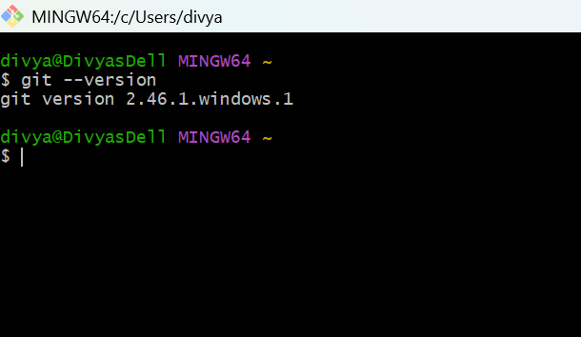
Opened GitHub Account
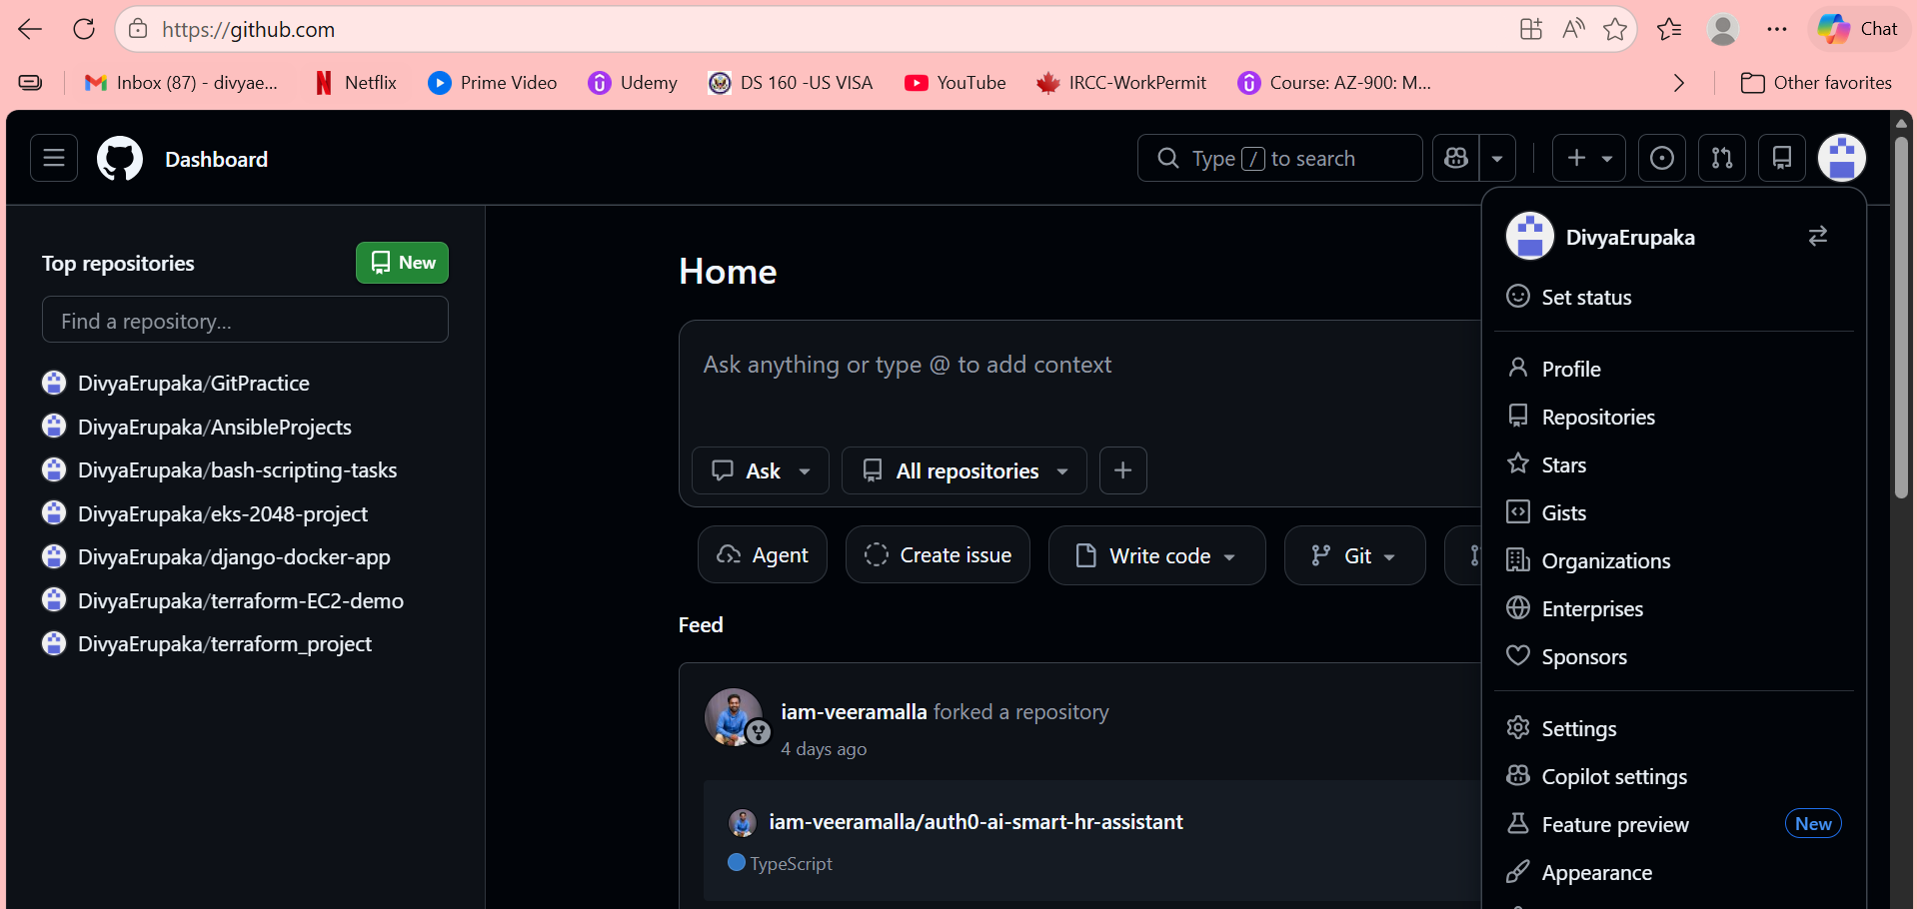
2. Create a Repository in GitHub with README.md and .gitignore
- Login to GitHub
- Click New Repository
- Enter repository name – MyGitProject
Added Description
- Select:
Add README.md
Add .gitignore
- Click Create Repository
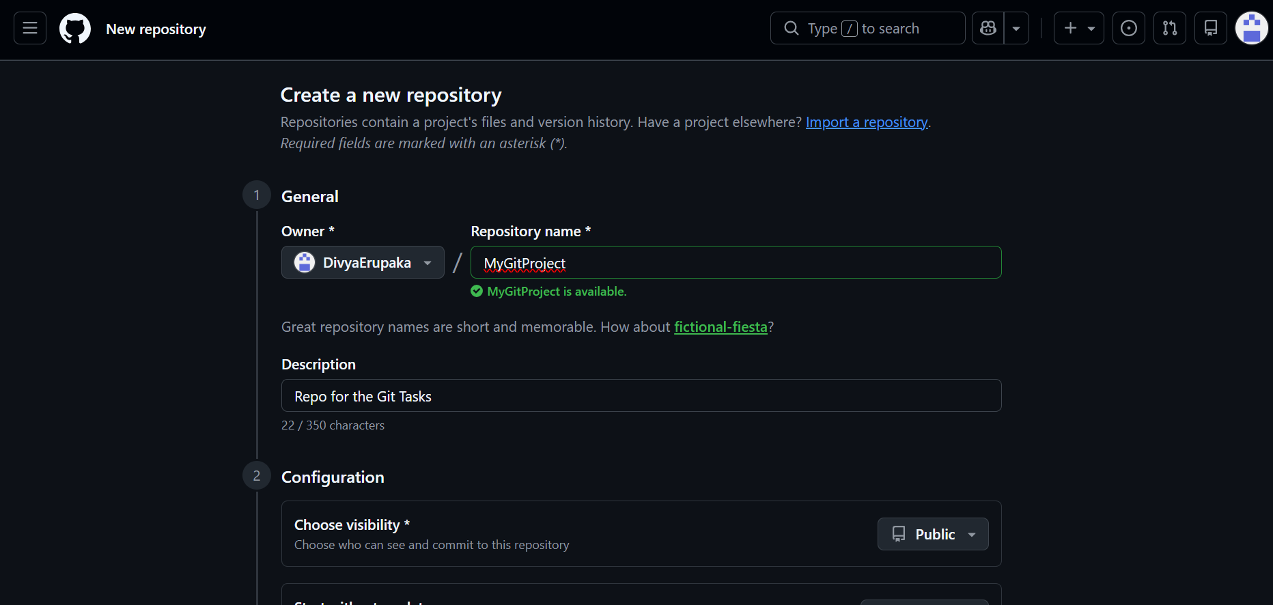
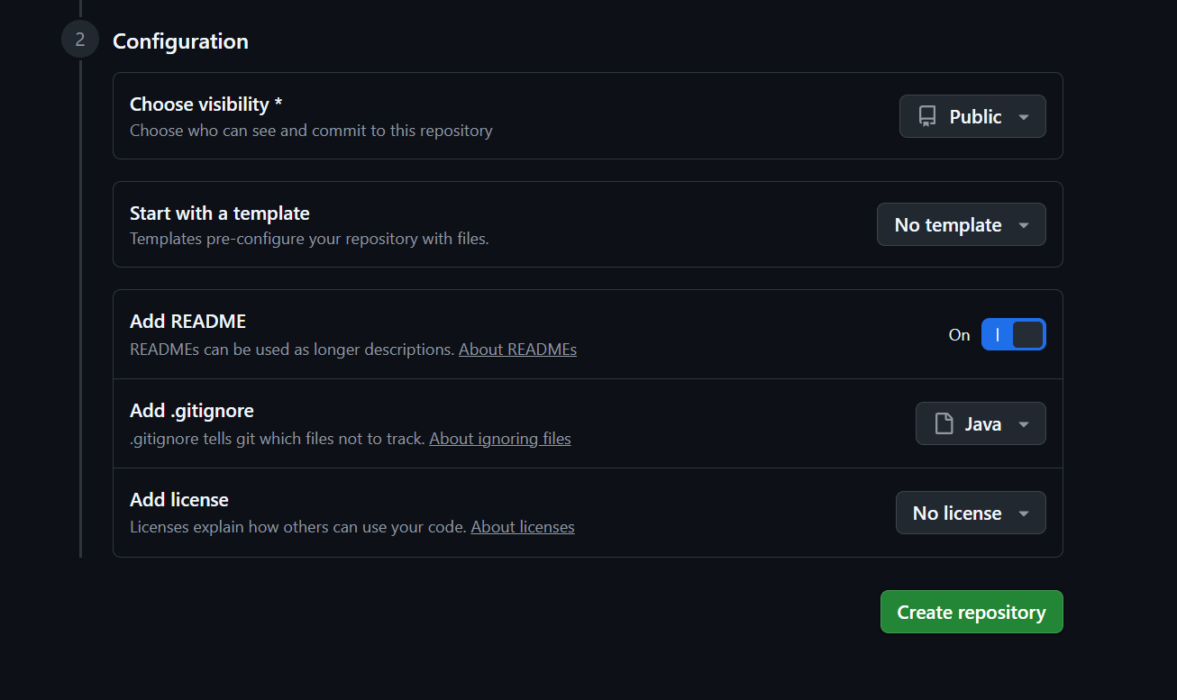
Created the Repo Succesfully.
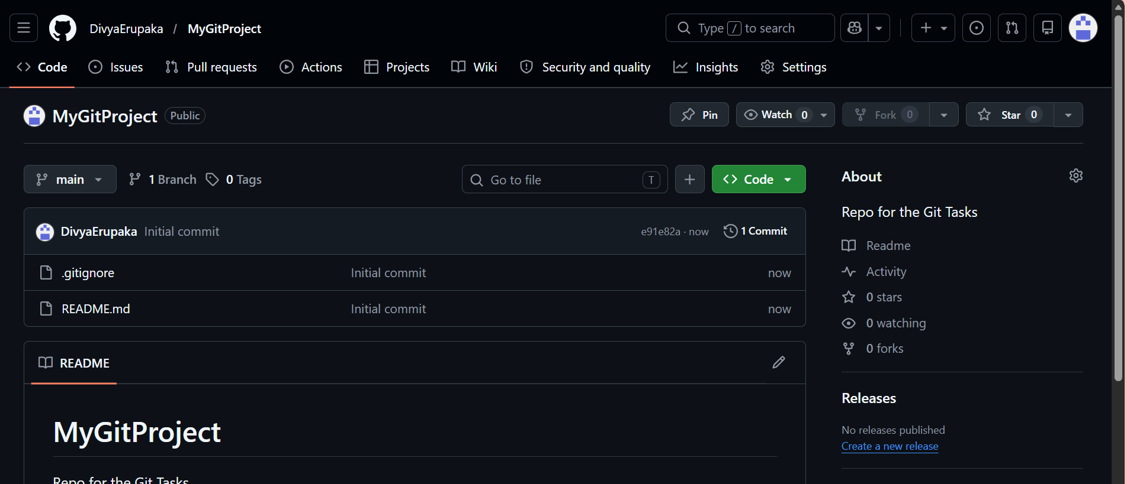
3. Clone the Created Repo to Local
moved into directory that where I want the repo to be cloned.
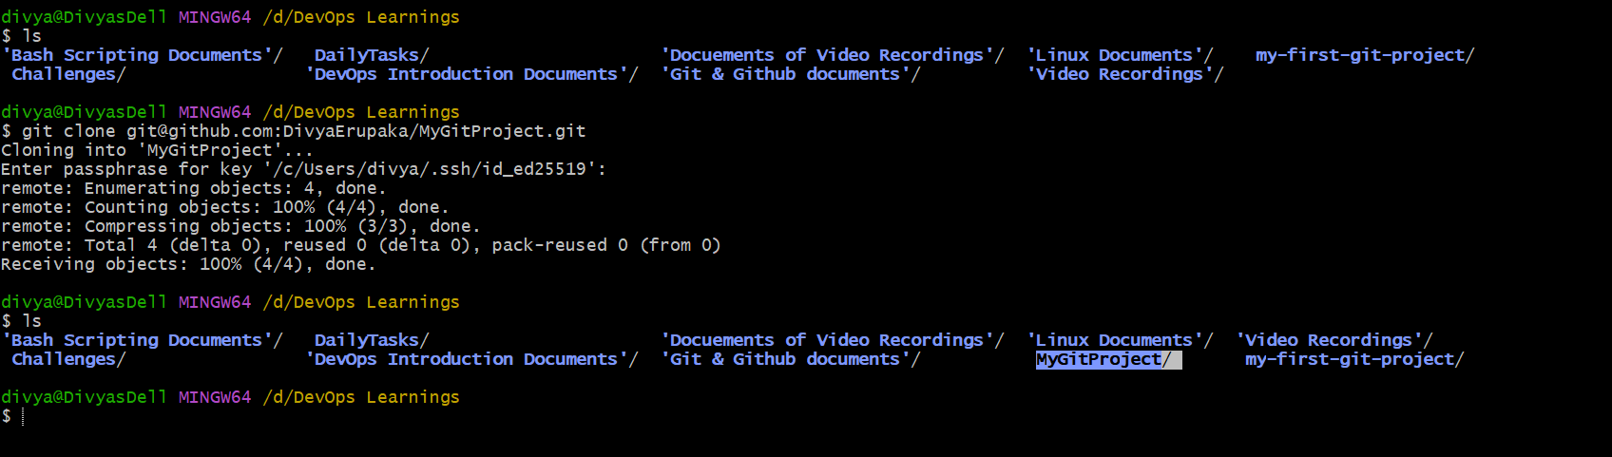
Repo is now cloned successfully.
4. Created the files in my local Repo
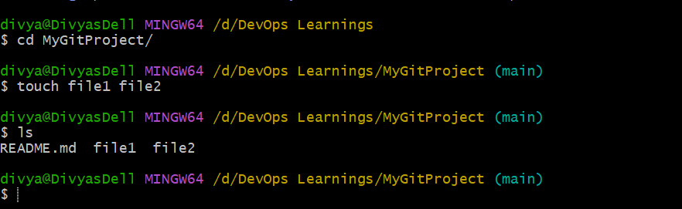
5. Commit Two Files and Push to Central Repository
Git follows a three-step workflow:
- Working Directory
- Staging Area
- Repository Commit
The git add command moves files to the staging area. The git commit command saves the changes locally with a commit message. Finally, git push uploads the changes to the central GitHub repository.
Commands
Check status: git status
Add files: git add .
Commit files: git commit -m "Added two files"
Push to GitHub: git push -u origin master
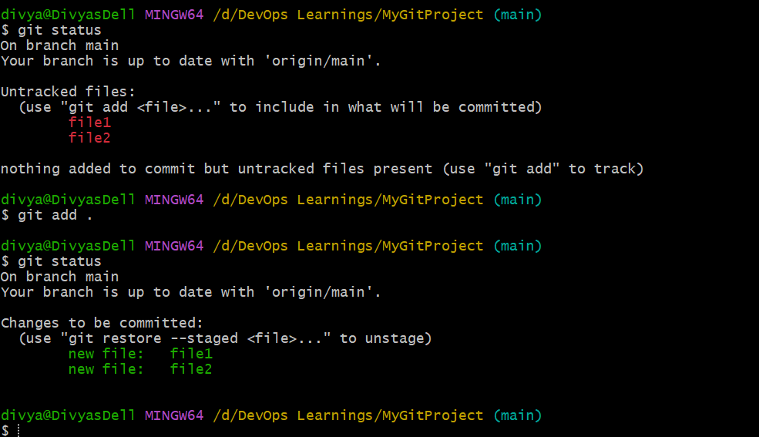
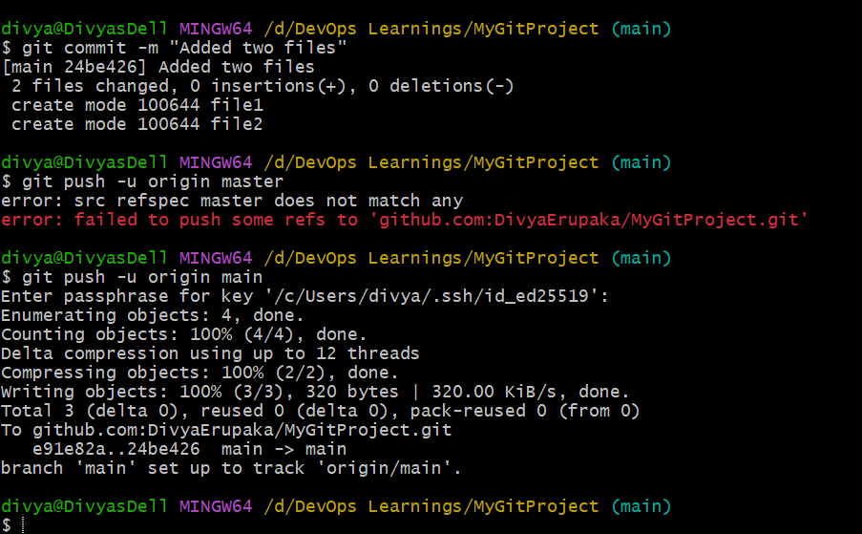
6. Create a Branch in Local and Create a Sample File and Push to Central
Branches in Git are used to work on new features or changes separately without affecting the main branch. In this task, a new branch named feature was created from the main branch. After switching to the new branch, a sample file named sample.txt was created. The file was then added to the staging area, committed to the local repository, and finally pushed to the remote GitHub repository.
Explanation of Commands
- git branch --list
Displays all available local branches.
- git branch feature
Creates a new branch named feature.
- git checkout feature
Switches from the current branch to the feature branch.
- touch sample.txt
Creates a new empty file named sample.txt.
- ls
Lists all files in the current directory.
- git add .
Adds all modified and new files to the staging area.
- git status
Shows the current status of files in the repository.
- git commit -m "Added sample file in feature branch"
Saves the staged changes into the local Git repository with a commit message.
- git push -u origin feature
Pushes the feature branch to the remote GitHub repository and sets upstream tracking.
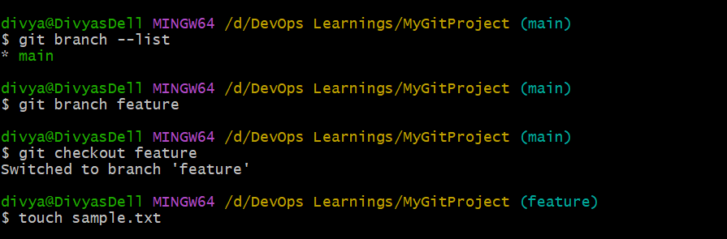
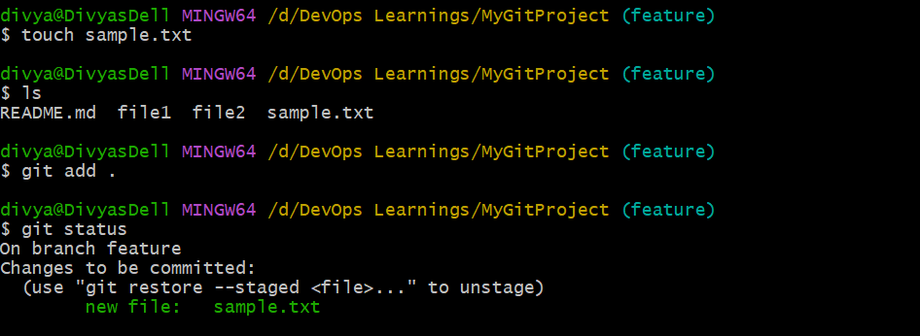
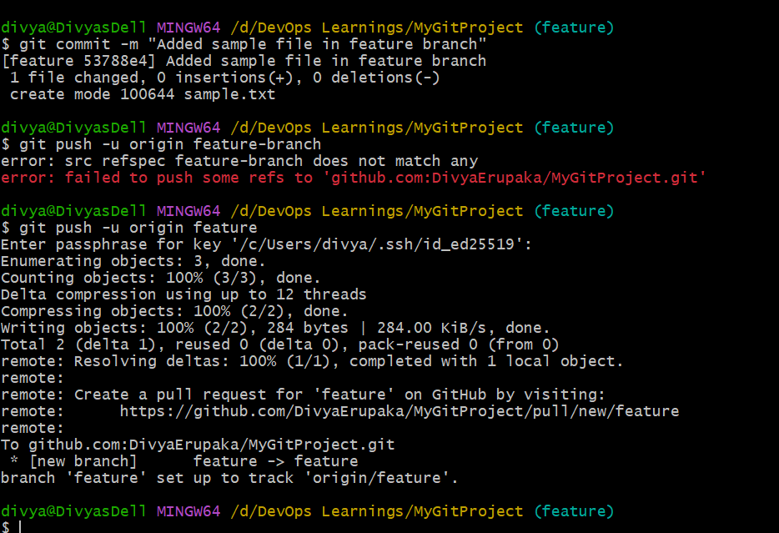
7. Create a branch in GitHub and clone it to your local.
This Git session demonstrates checking local branches, fetching updates from a remote repository, and creating a local branch from a newly discovered remote branch.
Initially, the local branches were the main feature.
After running git fetch, Git detected a new remote branch, Develop, and stored it under origin/Develop, but it did not automatically create a local branch.
Then, the command git checkout -b Develop origin/Develop was used to create a new local branch named Develop and set it to track the remote branch.
Finally, running git branch --list confirmed that Develop is now the active branch, along with existing branches main and feature.
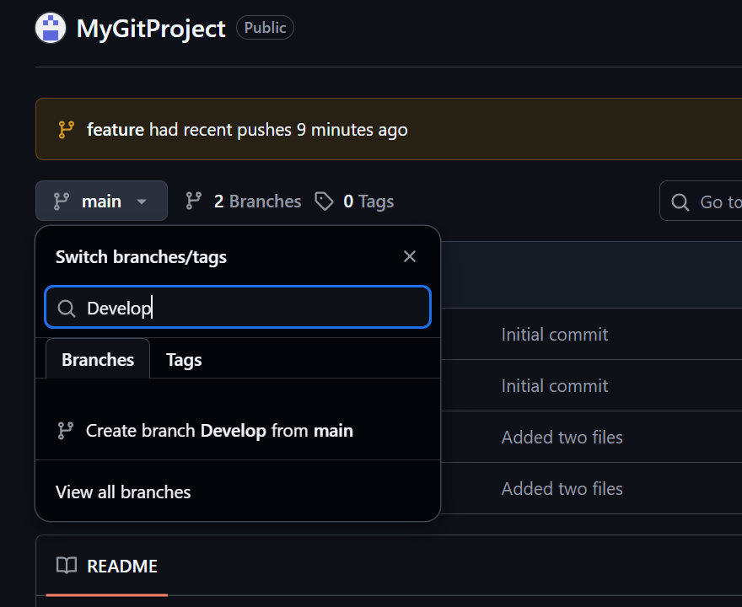
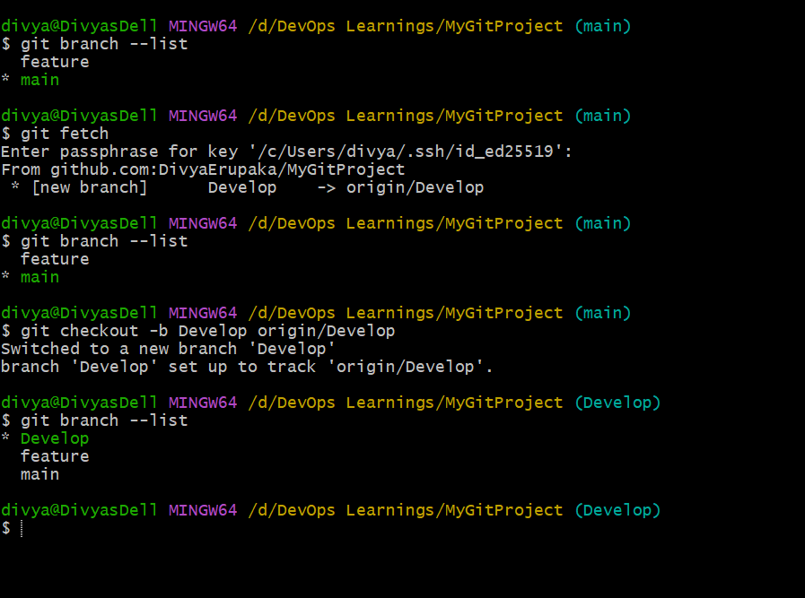
8.Merge the created branch with master in git local.
To merge your created branch (Develop) into main locally in Git, follow these steps:
First, switch to the branch you want to merge into (Develop):
git checkout develop
created dev.txt file and added content.
Now switch to main branch and run git merge develop
I created a real change in my workflow by switching to the Develop branch and adding a new file dev.txt, then committing it with the message “Added dev file in Develop.” This created a new commit that existed only in the Develop branch, which differed from main.
When I switched back to main and ran git merge Develop, Git performed a fast-forward merge because main had no new commits after the common base. Instead of creating a merge commit, Git simply moved main forward to include the new commit from Develop. As a result, dev.txt now exists in both branches, and both branches are back in sync.
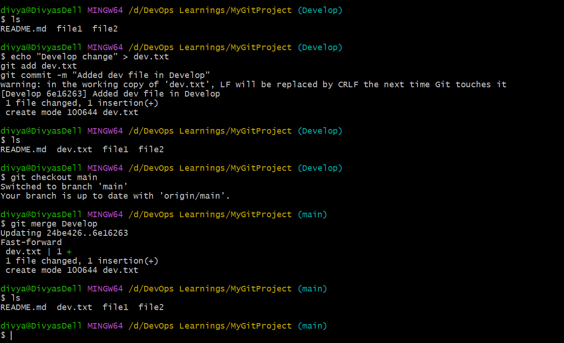
9. Merge the created branch with master in github by sending a pull request.
To merge your Develop branch into main (master) on GitHub using a Pull Request, follow these steps:
First, make sure your local changes are pushed to GitHub:
git push -u origin Develop
This sends your Develop branch (including dev.txt and its commit) to the remote repository.
Now open your repository in GitHub in your browser. You will usually see a banner saying “Compare & pull request” for the Develop branch. Click it. If not, go to the Pull Requests tab and select New pull request.
Set:
- base branch: main
- compare branch: Develop
Review the changes (you should see dev.txt being added), then click Create pull request. After that, click Merge pull request and confirm the merge. Once merged, main will include the changes from Develop.
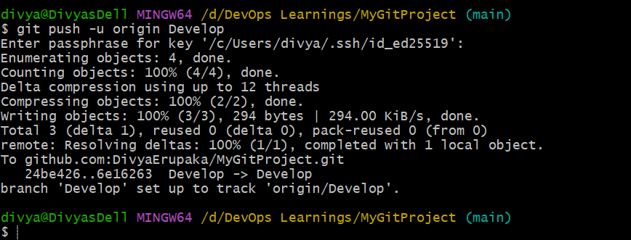
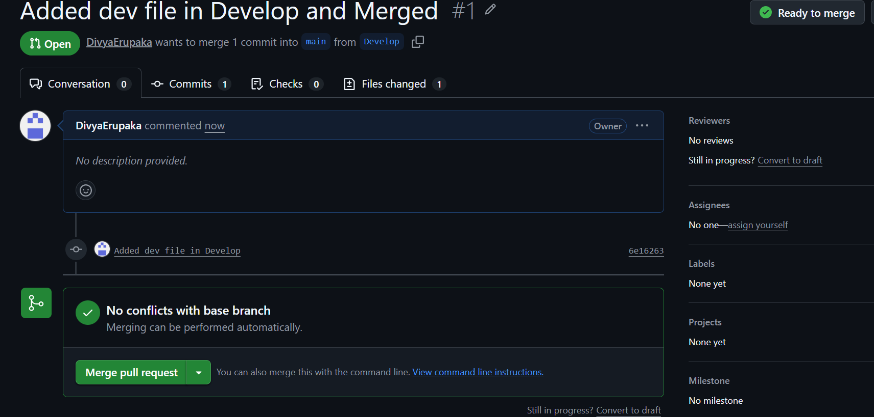
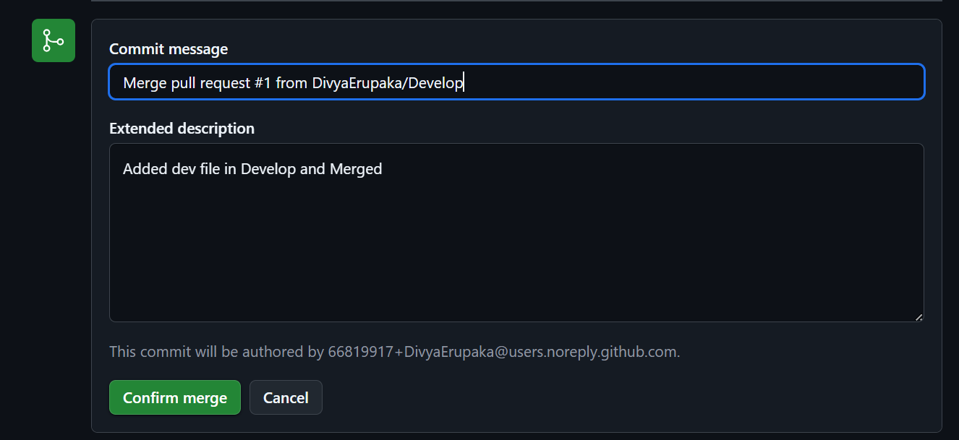
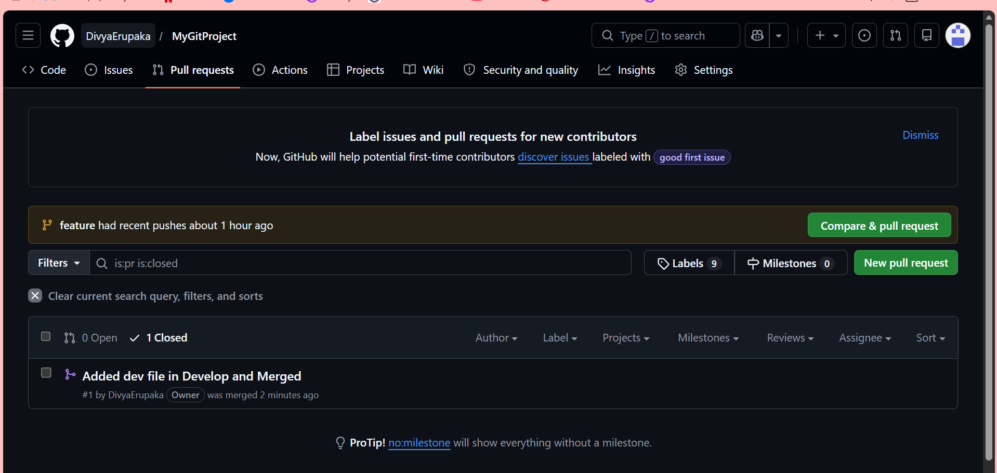
10. Create a file in local and send that to branch in github.
Switched to existing feature branch using: git checkout feature
Created a new file in the branch: echo "This file is created in existing branch" > demo.txt
Staged the file: git add demo.txt
Committed the changes: git commit -m "Added file in feature branch"
Pushed the branch to GitHub: git push origin feature
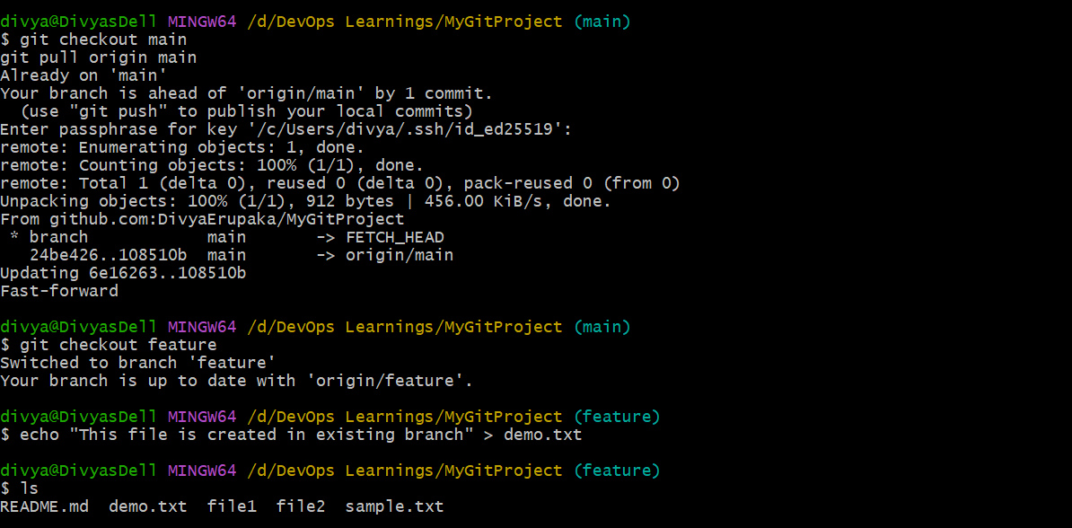
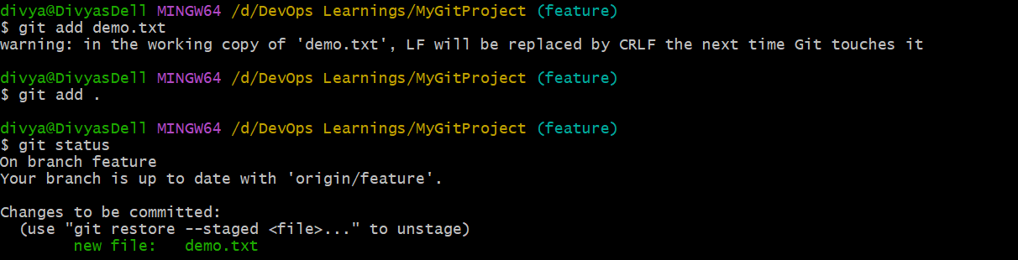
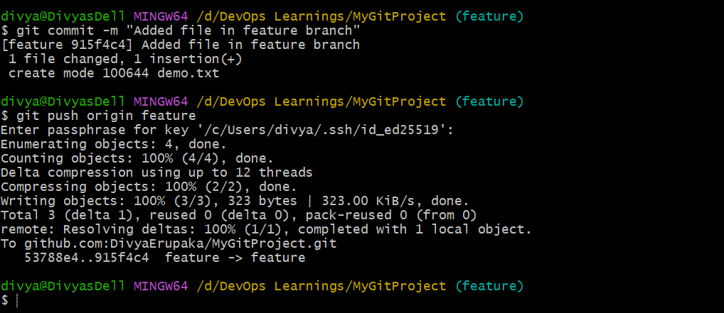
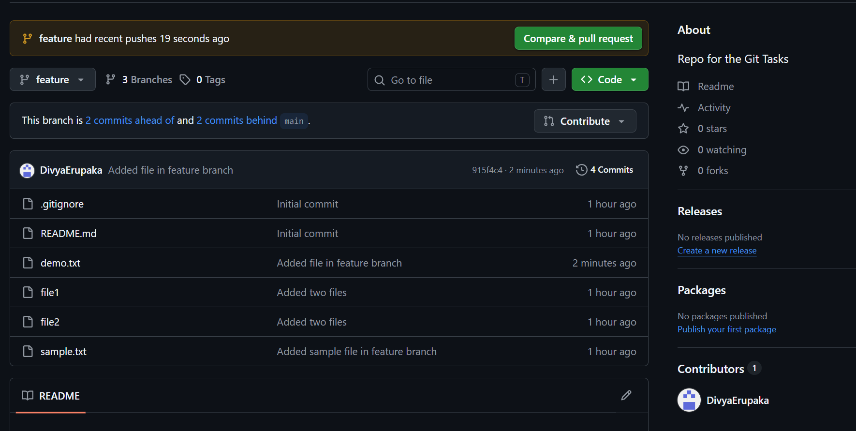
11. Clone only a branch from GitHub to the local.
To clone only a specific branch from GitHub to a local system, use the --branch option along with --single-branch. This ensures that only the selected branch is downloaded, rather than the entire repository with all branches. The command format is git clone --branch <branch-name> --single-branch <repository-url>. For example, git clone --branch feature --single-branch https://github.com/username/MyGitProject.git will clone only the feature branch into the local system.
After cloning, only the specified branch will be available locally, and the working directory will automatically switch to that branch. Other branches from the repository will not be downloaded, which helps save time and storage when only one branch is needed.
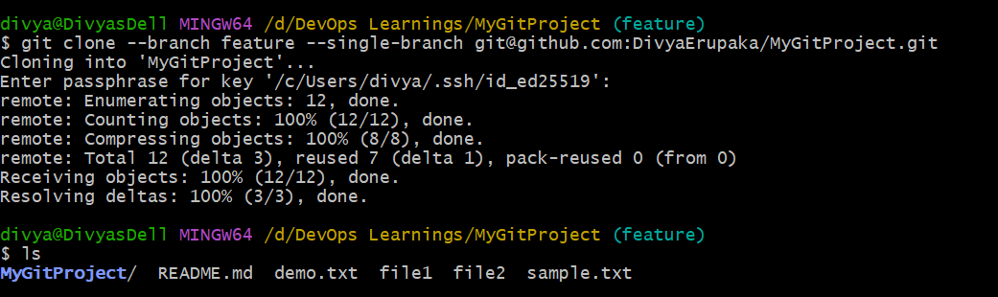
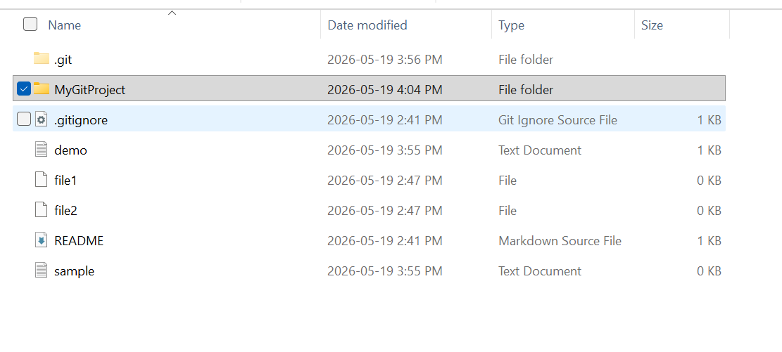
12. Create a file with all passwords and make that untrackable with git.
Objective
Create a file containing passwords and ensure Git does not track or push it to the repository using .gitignore.
Steps
1. Switch to working branch
git checkout develop
2. Create password file
echo "admin=1234" > passwords.txt
3. Add file to .gitignore
echo "passwords.txt" >> .gitignore
4. Verify Git status
git status
Expected:
- passwords.txt appears as untracked
- It is NOT staged for commit
5. Stage .gitignore
git add .gitignore
6. Commit changes
git commit -m "Add passwords file to gitignore"
7. Push branch (optional)
git push origin feature
Verification
Check tracking status
git status
Expected result:
working tree clean
Confirm file is ignored
git check-ignore -v passwords.txt
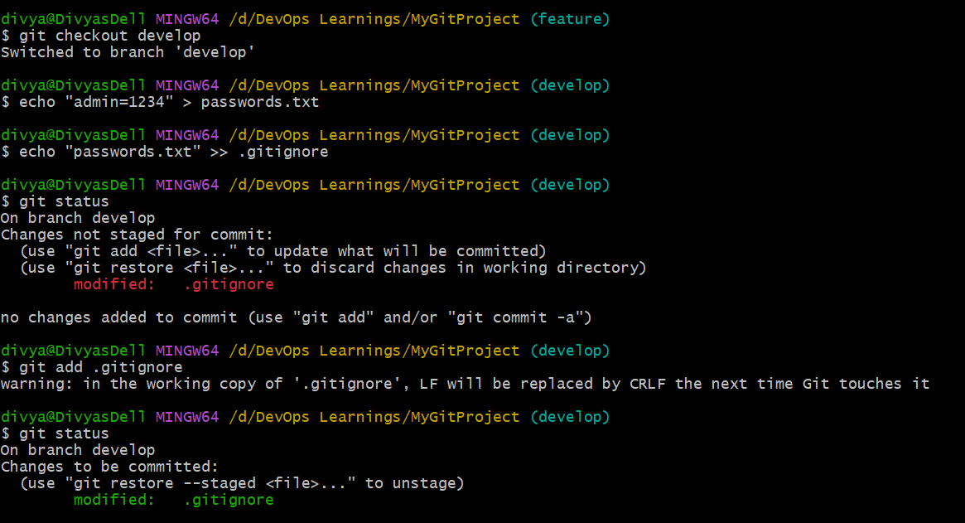
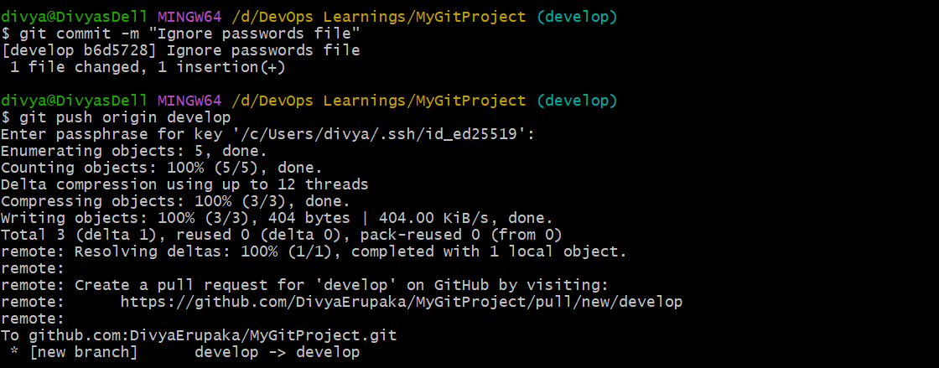
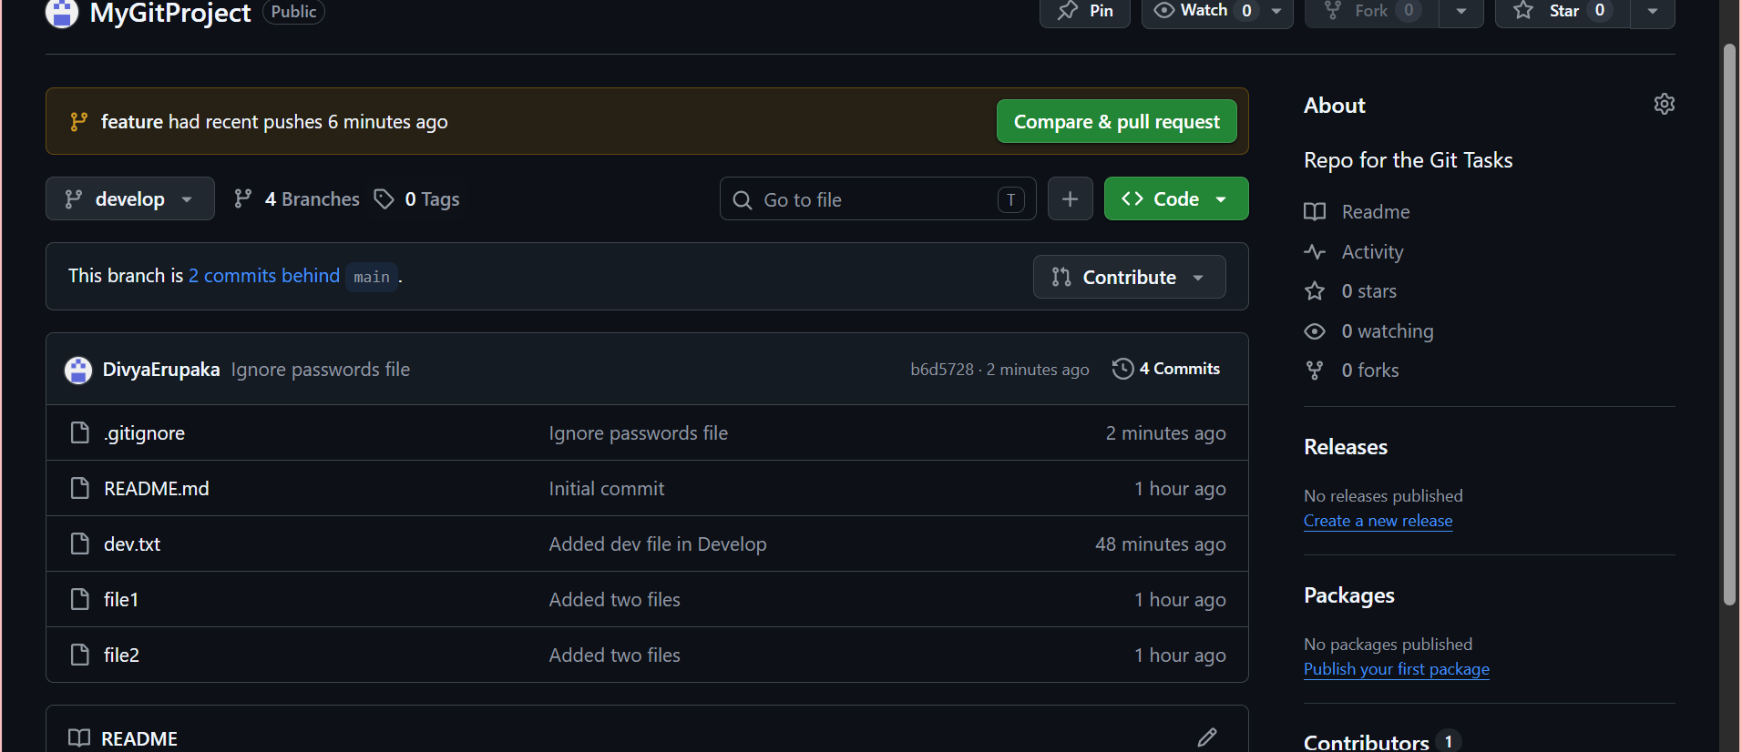
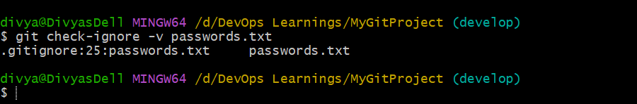
13. Make a commit and make that commit reset without saving changes.
Objective: Create a new file in a working branch, commit the changes, and then remove the commit completely without keeping any changes in the repository.
Step-by-Step Procedure
Step 1: Switch to the Working Branch
git checkout feature
Verification
git branch
Expected Output:
* feature
main
Step 2: Create a New File
echo "sample reset data" > resetdemo.txt
Verification
ls
Expected Output:
resetdemo.txt
Step 3: Stage the File
git add resetdemo.txt
Verification
git status
Expected Output:
Changes to be committed:
new file: resetdemo.txt
Step 4: Create a Commit
git commit -m "Added reset demo file"
Verification
git log --oneline
Expected Output:
<commit-id> Added reset demo file
Step 5: Reset the Commit Without Saving Changes
git reset --hard HEAD~1
Explanation
- HEAD~1 moves branch back by one commit
- --hard removes:
  - commit history
  - staged changes
  - working directory changes
Verification Steps
Verify Commit Removal
git log --oneline
Expected Result:
- Added reset demo file commit should NOT appear
Verify File Removal
ls
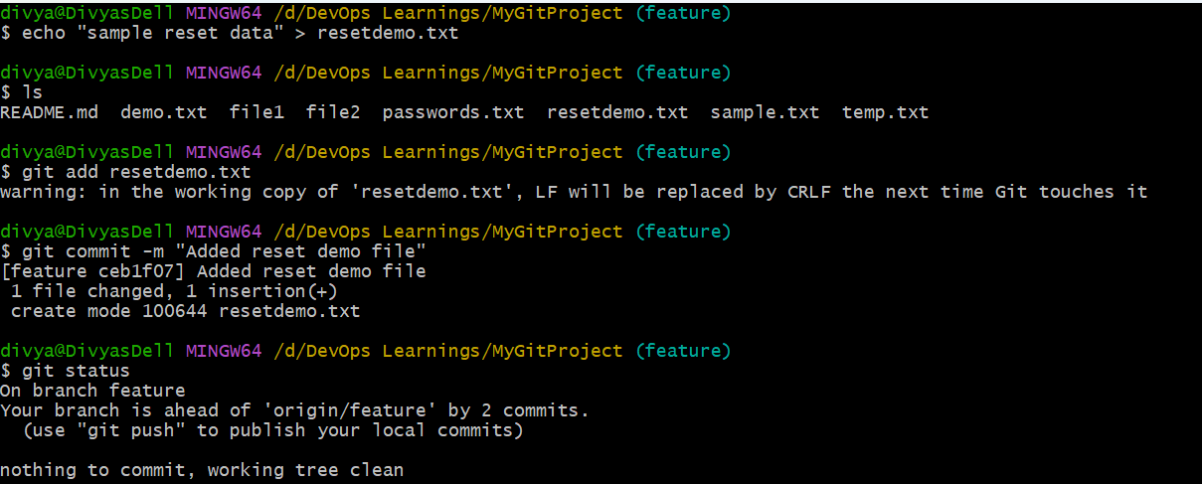
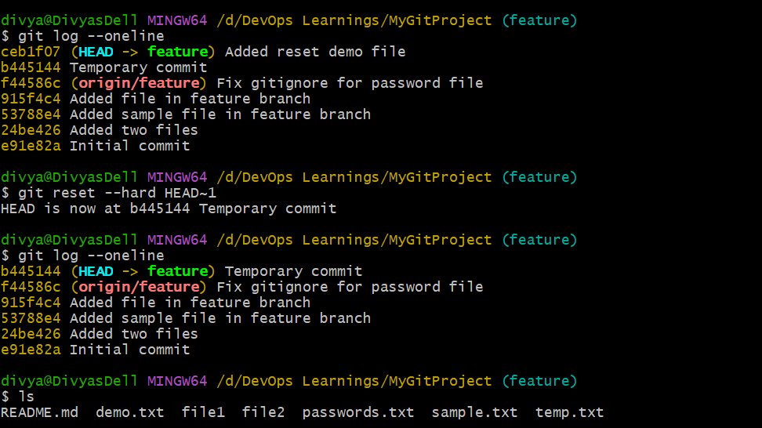
14. Revert a commited commit to the older version.
Objective: Restore the repository to an older version by reverting changes introduced in a committed commit without deleting commit history.
Step-by-Step Procedure
Step 1: Check Commit History
git log --oneline
Step 2: Identify the Commit to Revert
Suppose the following commit must be reverted:
915f4c4 Added file in feature branch
Step 3: Revert the Commit
git revert 915f4c4
What Happens
- Git creates a new commit
- Changes from commit 915f4c4 are reversed
- Previous commit history remains intact
- Safer than git reset for shared repositories
Verification Steps
Verify Commit History
git log --oneline
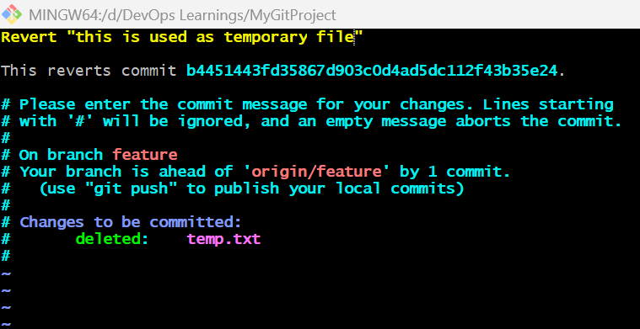
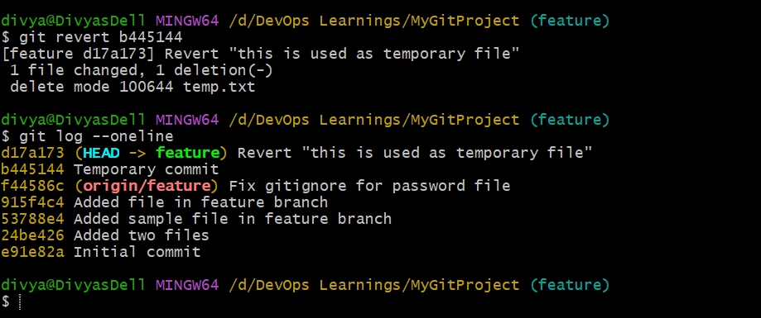
15. Push a file to stash without savings the changes and work on another file.
Objective: Temporarily save current file changes in Git stash without committing them and continue working on another file in the same branch.
Step-by-Step Procedure
Step 1: Switch to Working Branch
git checkout feature
Verification
git branch
Expected Output:
* feature
main
Step 2: Create a Temporary File
echo "temporary work" > tempwork.txt
Step 3: Verify File Status
git status
Expected Output:
Untracked files:
tempwork.txt
Step 4: Push File to Stash
Since tempwork.txt is an untracked file, use:
git stash -u
Explanation
- -u or --include-untracked
- Saves tracked and untracked files into stash
- Removes temporary changes from working directory
Step 5: Verify Working Directory
git status
Expected Output:
working tree clean
Step 6: Verify Stash Storage
git stash list
Expected Output:
stash@{0}: WIP on feature
Step 7: Work on Another File
Create another file:
echo "new development work" > anotherfile.txt
Step 8: Stage and Commit New Work
git add anotherfile.txt
git commit -m "Added another file"
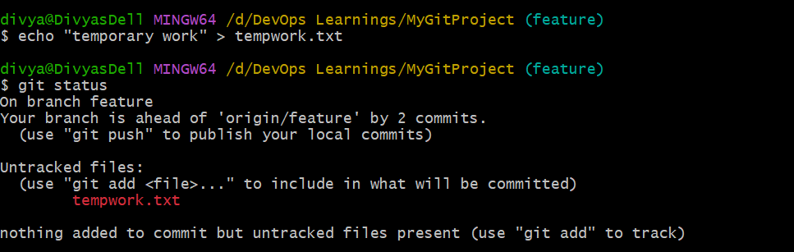
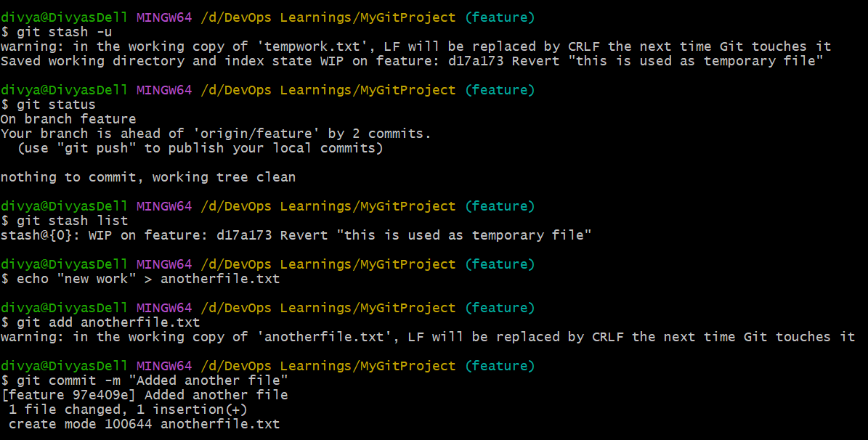
16. Undo the stash file and start working on that again.
Objective: Restore a stashed file back to the working directory and continue editing or modifying the file.

Step-by-Step Procedure
Step 1: Check Available Stash Entries
git stash list
Expected Output:
stash@{0}: WIP on feature
Step 2: Restore the Stashed File
Restore and Remove Stash (Recommended)
git stash pop
Explanation
- Restores stashed files to working directory
- Removes stash entry after restoration
Step 3: Verify Restored File
ls
Expected Output:
tempwork.txt
Step 4: Verify Git Status
git status
Expected Output:
modified: tempwork.txt
Step 5: Continue Working on the File
Modify the file again:
echo "additional work" >> tempwork.txt
Step 6: Verify Updated Content
cat tempwork.txt
Expected Output:
temporary work
additional work
Verification Steps
Check Stash List Again
git stash list
Expected:
- If git stash pop was used → stash removed
- If git stash apply was used → stash still exists
Verify Working Directory
git status
Expected:
- Restored file visible
- Changes ready for further work
Command | Purpose
git stash pop | Restore and remove stash
git stash apply | Restore without deleting stash
git stash list | View saved stashes
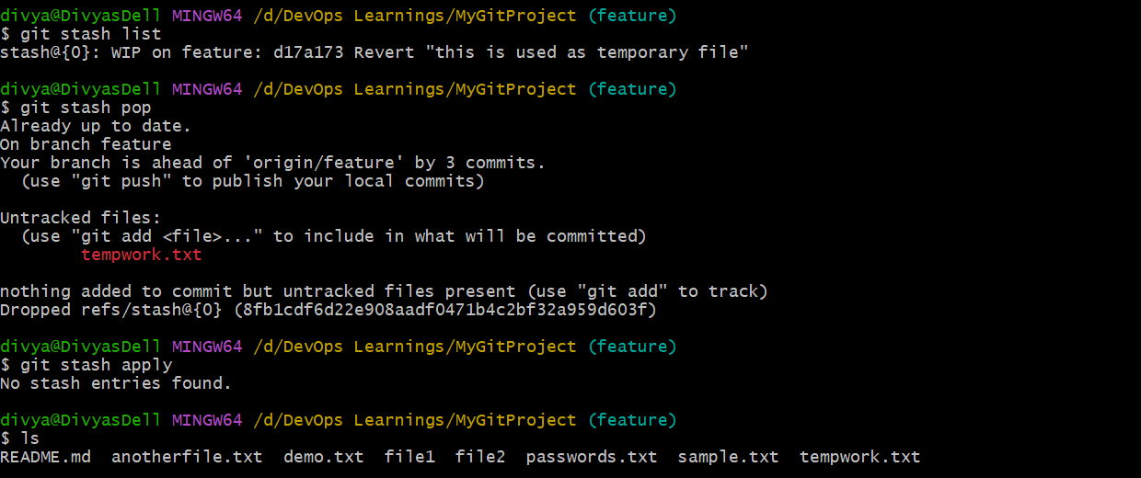
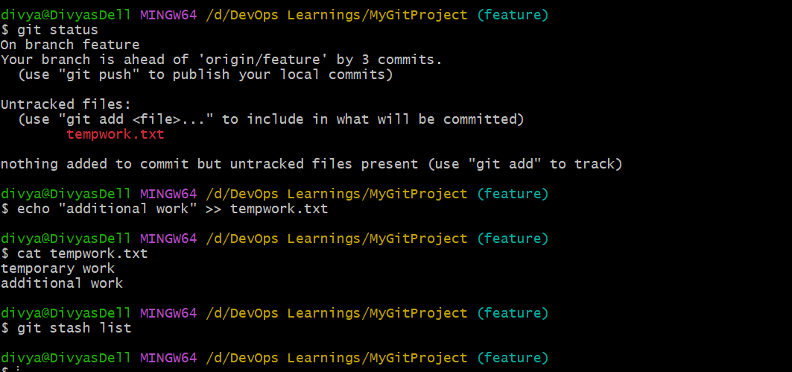
17. Generate a ssh-keygen and configure into github.
Objective: Generate an SSH key pair using Git Bash and configure the public key in GitHub to enable secure authentication for Git operations.
Procedure
Step 1: Generate SSH Key Pair
SSH keys were generated in Git Bash using the ssh-keygen command. During this process, two files were created inside the .ssh directory:
- id_ed25519 → Private key
- id_ed25519.pub → Public key
The private key remains securely stored in the local system, while the public key is used for GitHub authentication.
Step 2: Copy the Public Key
The contents of the id_ed25519.pub file were displayed and copied using Git Bash. The copied key starts with:
ssh-ed25519
This public key is safe to share with GitHub for authentication purposes.
Step 3: Configure SSH Key in GitHub
In GitHub:
- Opened GitHub Settings
- Navigated to:
  - SSH and GPG Keys
- Selected:
  - New SSH Key
The following details were provided:
- Title: Mylaptop2
- Key: Public key copied from id_ed25519.pub
After pasting the public key, the Add SSH Key option was selected, and the SSH key was successfully added to GitHub.
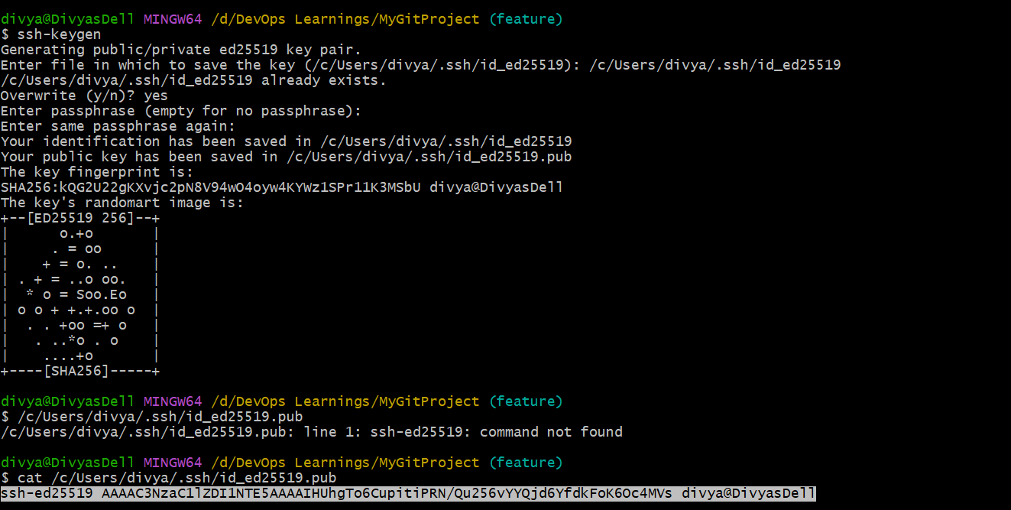
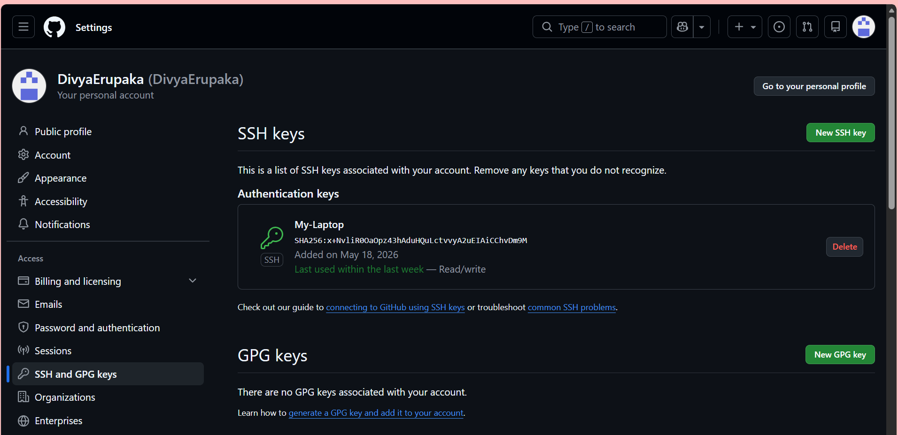
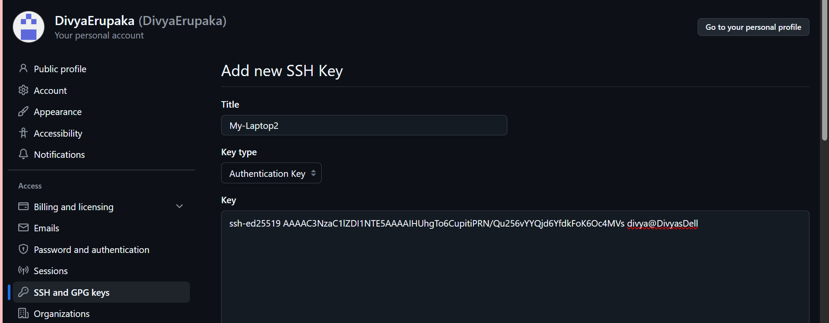
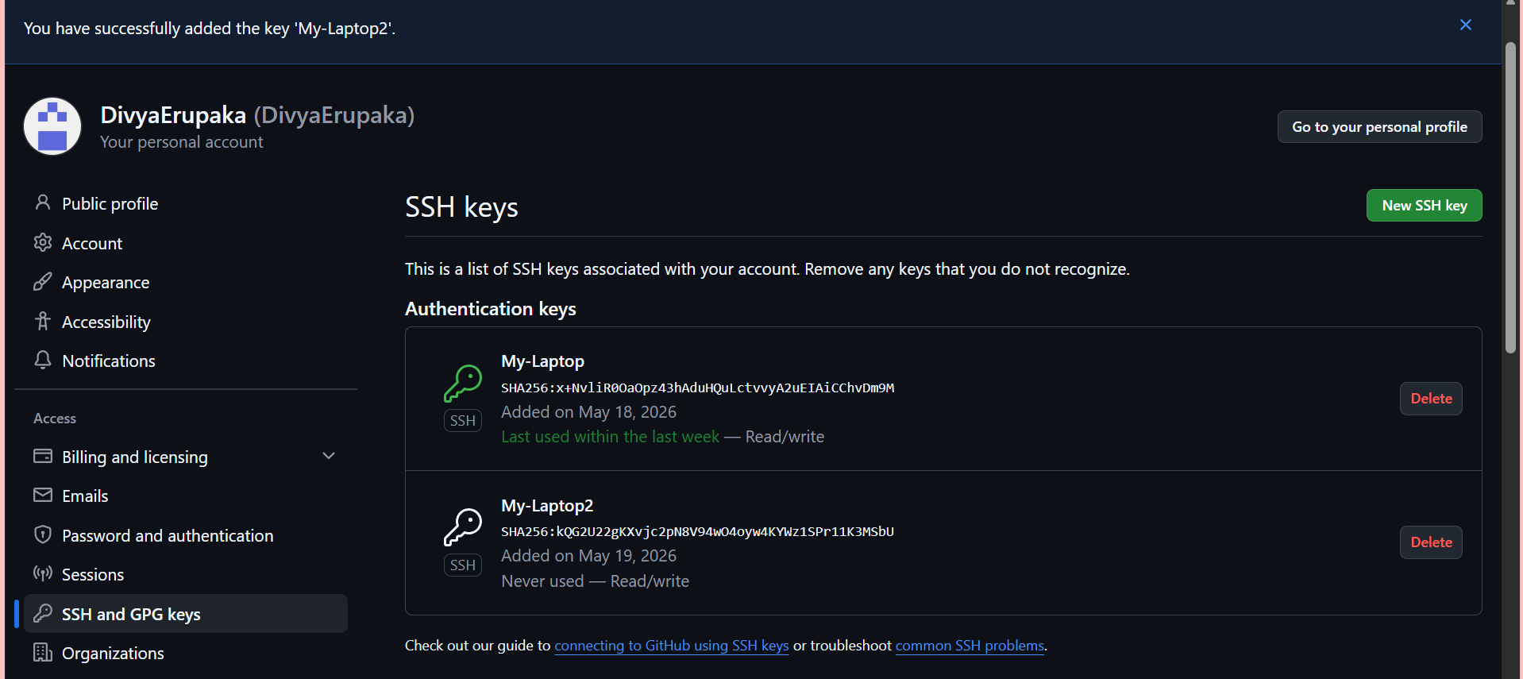
18. Configure webhooks to github.
Objective: Configure a webhook in GitHub to automatically send repository event notifications to an external application or server.
Step-by-Step Procedure
Step 1: Open GitHub Repository
Login to GitHub and open the required repository.
Example Repository:
GitHub
Step 2: Navigate to Repository Settings
Inside the repository:
- Click:
  - Settings
- Select:
  - Webhooks
Step 3: Add a New Webhook
Click:
Add webhook
Step 4: Configure Webhook Details
Payload URL
Enter the target server/application URL that should receive webhook events.
Example:
http://example.com/github-webhook/
Content Type
Select:
application/json
Secret (Optional)
Provide a secret token for secure communication between GitHub and the target application.
Example:
mysecretkey

Step 5: Select Events
Choose which events should trigger the webhook.
Options:
- Just the push event
- Send everything
- Let me select individual events
Common selection:
Just the push event
Step 6: Activate Webhook
Ensure:
Active
is checked.
Click:
Add webhook
Verification
Trigger Webhook
Make a change in the repository and push code:
git add .
git commit -m "Webhook test"
git push origin feature
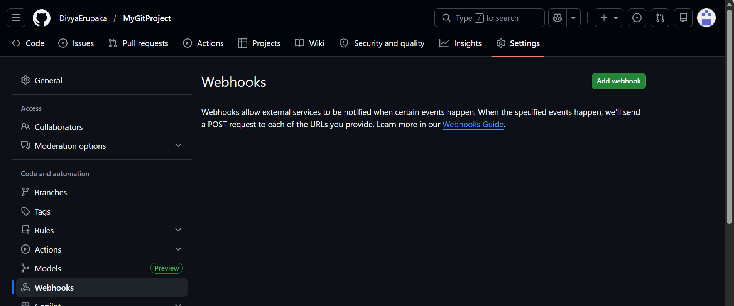
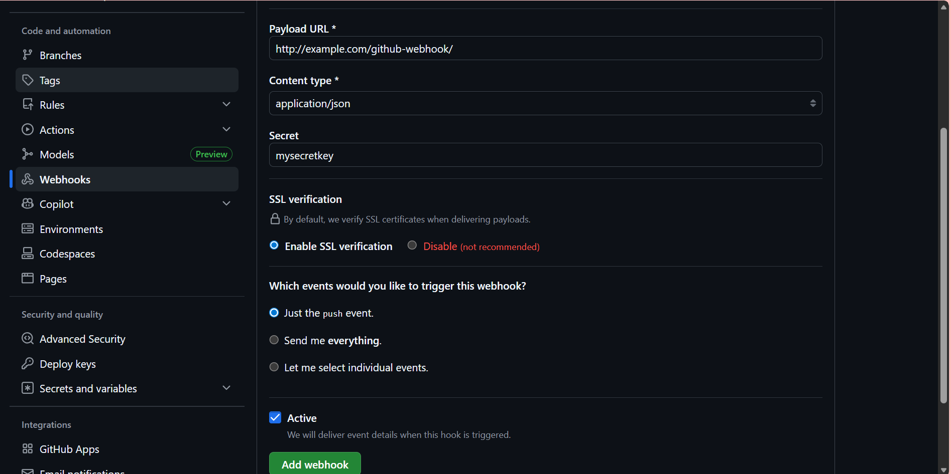
19.Basic understanding of .git file.
What is .git?
The .git directory is the hidden folder created automatically when a Git repository is initialized using:
git init
It is the core directory where Git stores all repository-related information such as commits, branches, history, configuration, and tracking details.
Location of .git
Inside the project folder:
MyGitProject/
├── .git/
├── README.md
├── file1
└── file2
The .git folder is usually hidden.
Purpose of .git
The .git directory helps Git:
- track file changes
- maintain commit history
- manage branches
- store repository configuration
- support rollback and recovery operations
Without .git, the folder is just a normal directory and Git commands will not work.
Important Contents Inside .git
File/Folder | Purpose
HEAD | Points to current branch
config | Repository configuration settings
objects/ | Stores commits and file data
refs/ | Stores branch and tag references
logs/ | Stores history of Git actions
index | Staging area information
Common Commands Related to .git
Initialize Git Repository
git init
Creates the .git directory.
View Hidden .git Folder
In Git Bash:
ls -a
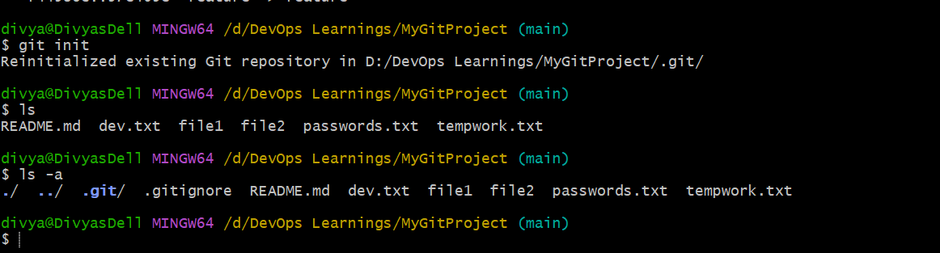Check Git Repository Status
git status
Git uses .git internally to track repository state.

Important Notes
- .git should never be deleted accidentally
- Removing .git removes complete Git history
- .git contains sensitive repository metadata
- .git is not manually edited in normal workflows
20.Check all the logs of git.
View Commit History
git log
Purpose
Displays:
- commit IDs
- author details
- commit messages
- timestamps
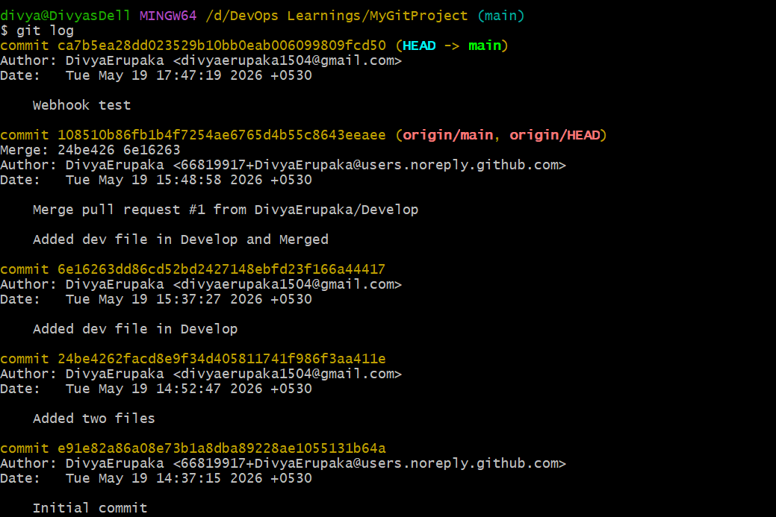
2. View Short Commit History
git log --oneline
Example Output
915f4c4 Added file in feature branch
53788e4 Added sample file
24be426 Added two files
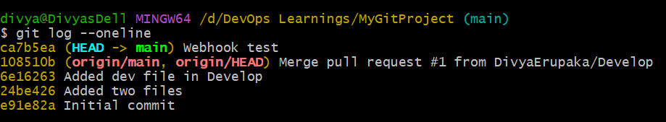3. View Commit History with Graph
git log --oneline --graph --all
Purpose
Displays:
- branch structure
- merges
- commit relationships
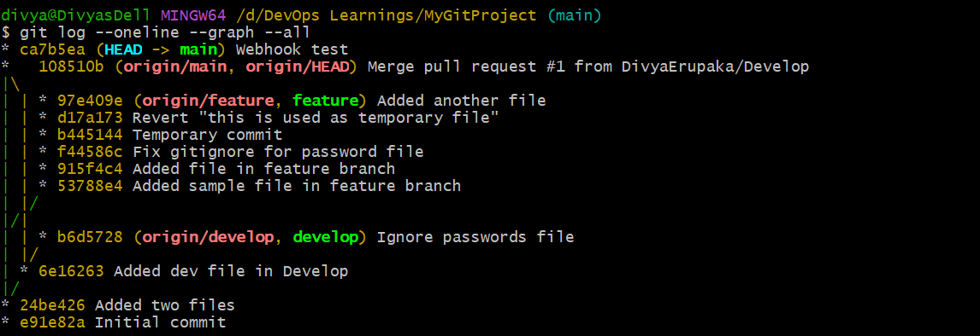

4. View Detailed Reference Logs (Reflog)
git reflog
Purpose
Shows:
- branch switching
- resets
- commits
- stash operations
- HEAD movement history
Example Output
HEAD@{0}: commit: Added file
HEAD@{1}: checkout: moving from main to feature
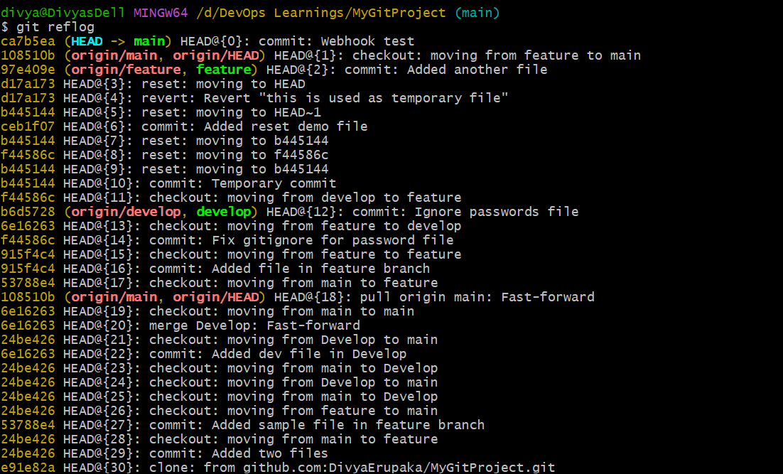

5. View Logs of Specific Branch
git log feature
OR
git log main
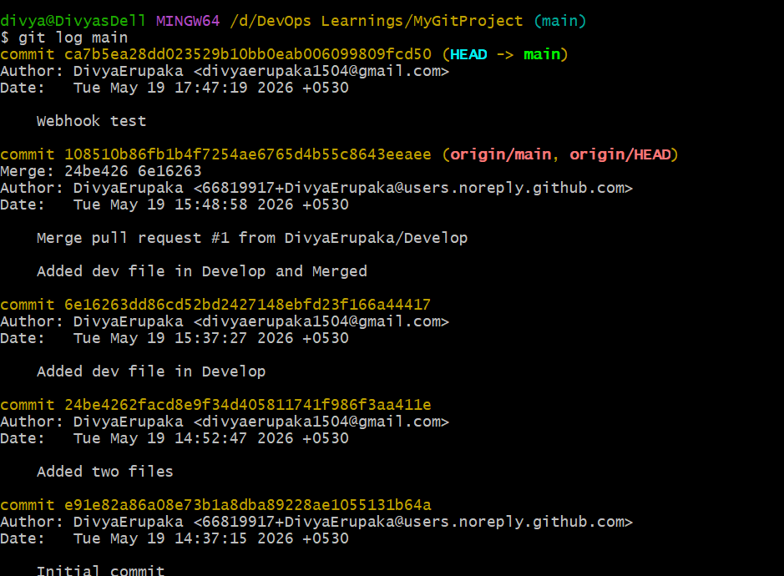

6. View Logs for a Specific File
git log demo.txt
Purpose
Displays commit history related only to that file.
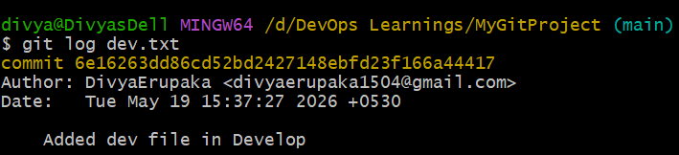
7. View Stash Logs
git stash list
Purpose
Displays all saved stash entries.
21. Rename the commit message.
Objective: Modify or rename an existing Git commit message.
Rename the Latest Commit Message
Step 1: Rename Last Commit
git commit --amend -m "Updated commit message"
Explanation
- --amend modifies the most recent commit
- -m specifies the new commit message

🔍 Verification
Check Updated Commit Message
git log --oneline
Expected Output:
<commit-id> Updated commit message
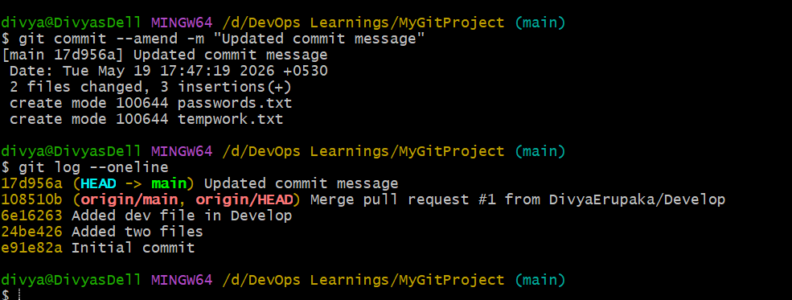
22. Merge multiple commits into single commit.
Objective
Combine multiple commits into one single commit using Git interactive rebase.
This process is called Squashing Commits.
Step-by-Step Procedure
Step 1: Check Commit History
git log --oneline
Example Output:
915f4c4 Added demo file
53788e4 Updated sample file
24be426 Added two files
Suppose these commits must be merged into one:
- 915f4c4
- 53788e4

Step 2: Start Interactive Rebase
To merge the last 2 commits:
git rebase -i HEAD~2

Step 3: Modify Rebase Instructions
Git opens an editor.
Initial View
pick 53788e4 Updated sample file
pick 915f4c4 Added demo file
Change to Squash
Replace second pick with squash:
pick 53788e4 Updated sample file
squash 915f4c4 Added demo file
Step 4: Save and Exit Editor
Git combines commits and opens another editor to modify the final commit message.
Example:
Added sample and demo files
Save and exit.
Verification
Check Updated Commit History
git log --oneline
Expected:
<new-commit-id> Added sample and demo files
24be426 Added two files
Multiple commits are now merged into one.
Important Notes
Command | Purpose
git rebase -i HEAD~2 | Interactive rebase for last 2 commits
squash | Merge commit into previous commit
Important Warning
If commits were already pushed to GitHub:
git push --force
is required after squashing commits.
Use force push carefully in shared repositories.
